Memory Leak Tests for Scale Project
8/15/2016

- By Module: Yield Curve, Rate Paths, Pricing, etc.
- Caching and No Caching
- Multiple loops of same process
- Identify leaks visually
- Use Leak detector (VLD) to ensure 2+ loops complete without memory leak

Going Forward:
- Run VLD command line
- Redirect VLD output to file
- Run for each module: Yield Curve, Rate Paths, Pricing, etc.
- Run Caching and No Caching
- 1 Loop for each process
- Check output files for leaks

Yield Curve x 1000
Stable
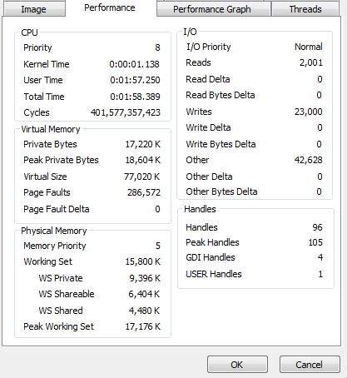
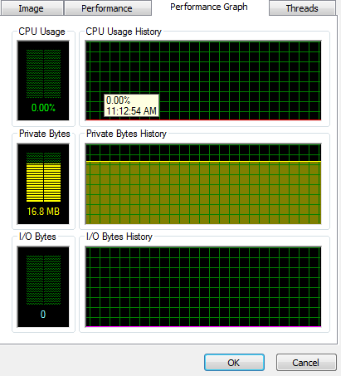

Repline X 1000
Stable
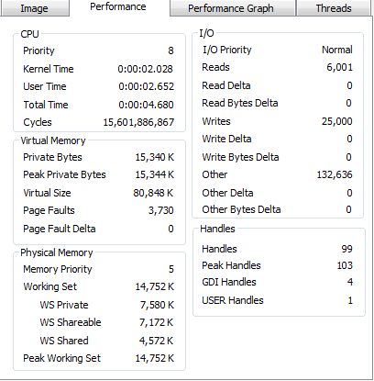
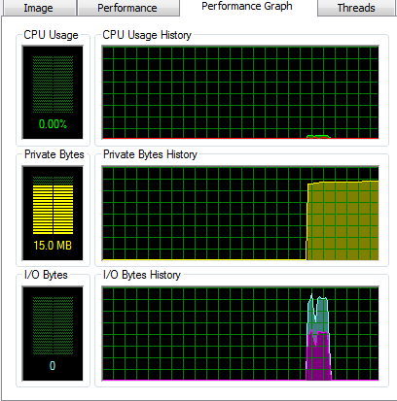

HPA Projection x 1000
Stable
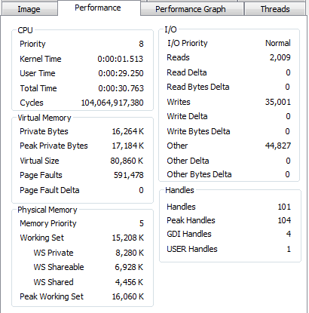
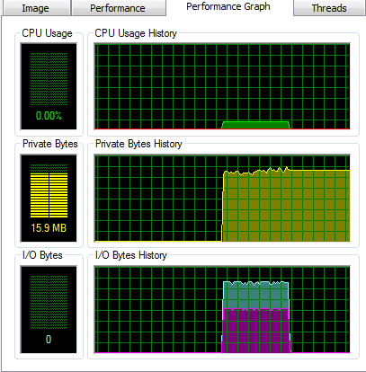

Credit Projection x 2000
Stable
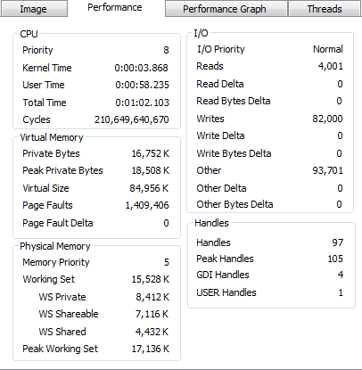

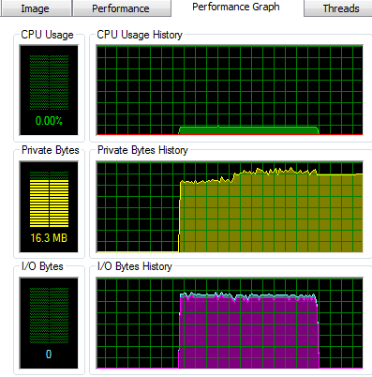

Rate Path Cache x 10 (no caching)
Seems Stable
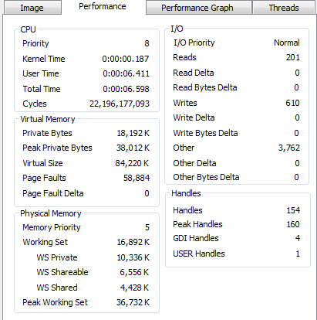

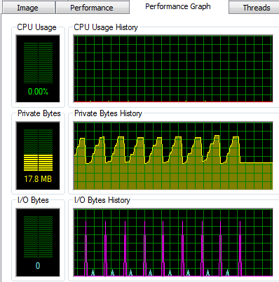

Rate Path Cache x 100 (with caching)
Stable
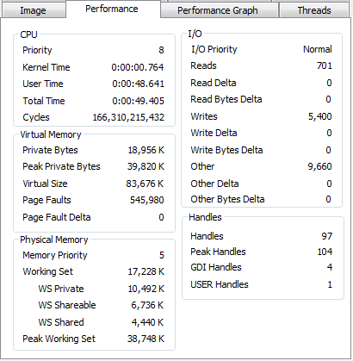

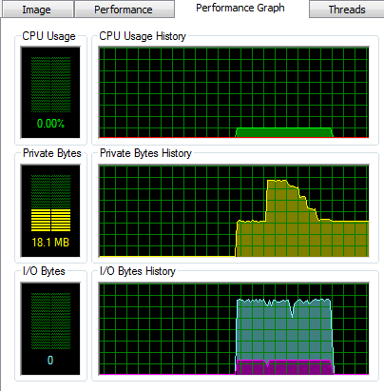

Rate Path Cache x 100 (no caching)
Stable
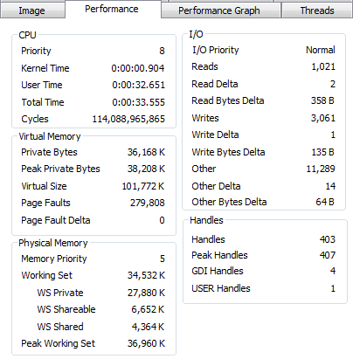

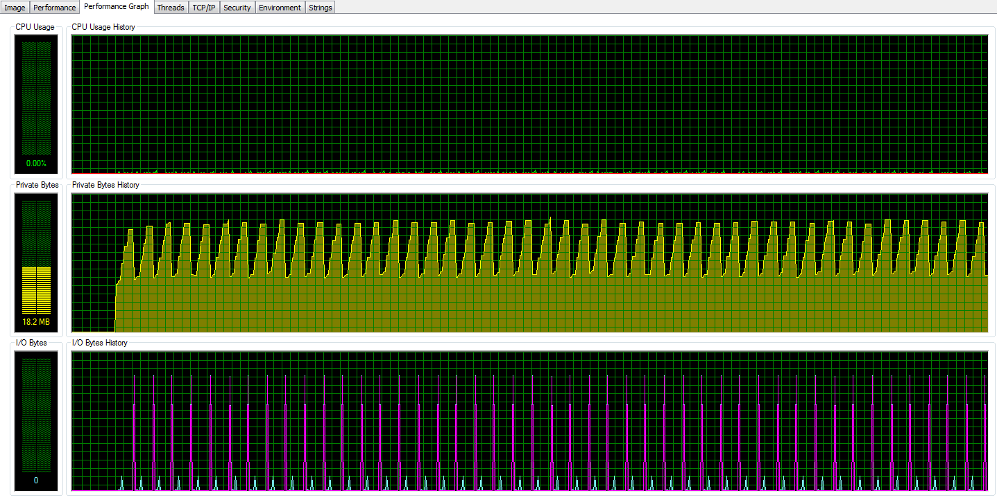

Mortgage Rate Projection x 10 (no caching)
Seems Stable
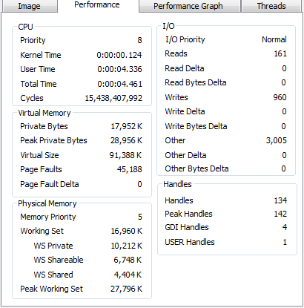

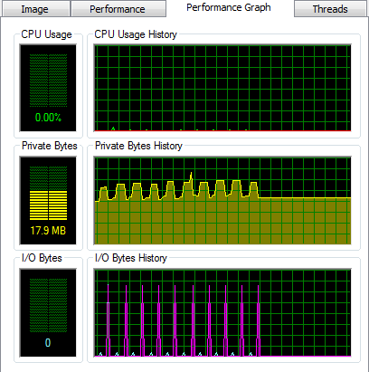

Mortgage Rate Projection x 100 (with caching)
Stable
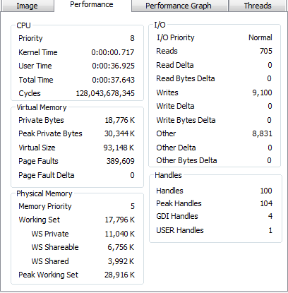

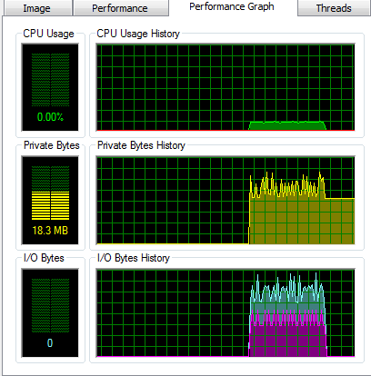

Mortgage Rate Projection x 100 (no caching)
Stable
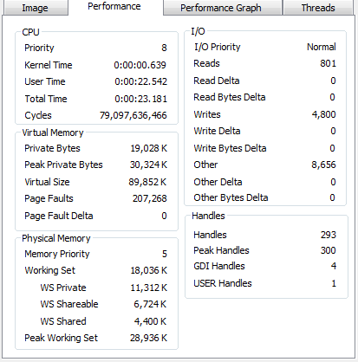

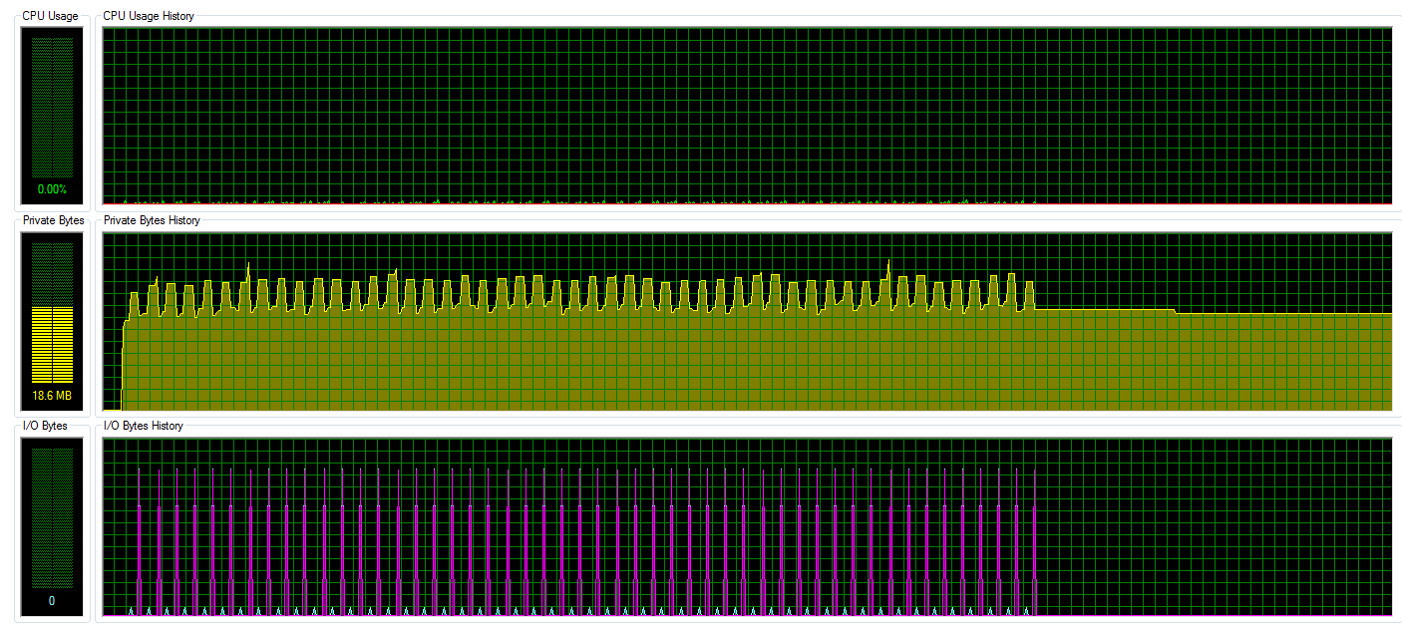

Media Effect Projection x 10 (no caching)
Stable

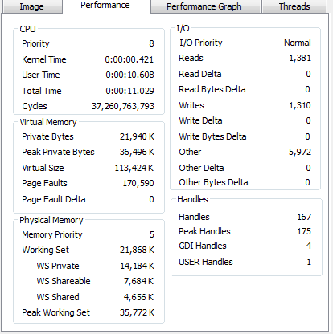

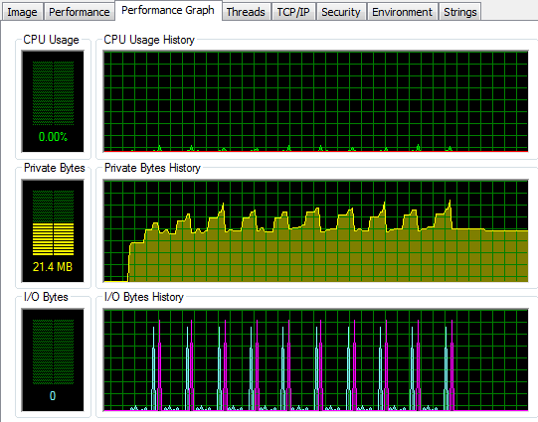

Media Effect Projection x 100 (with caching)
Stable
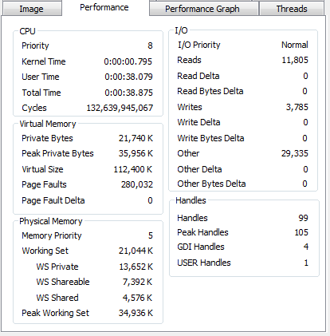

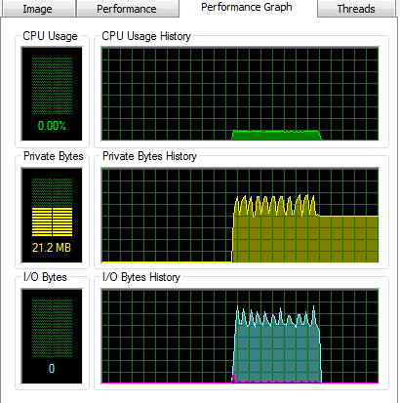

Media Effect Projection x 50 (no caching)
Stable

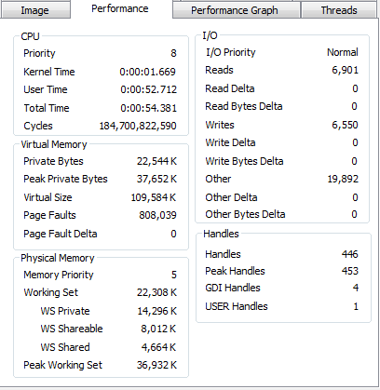

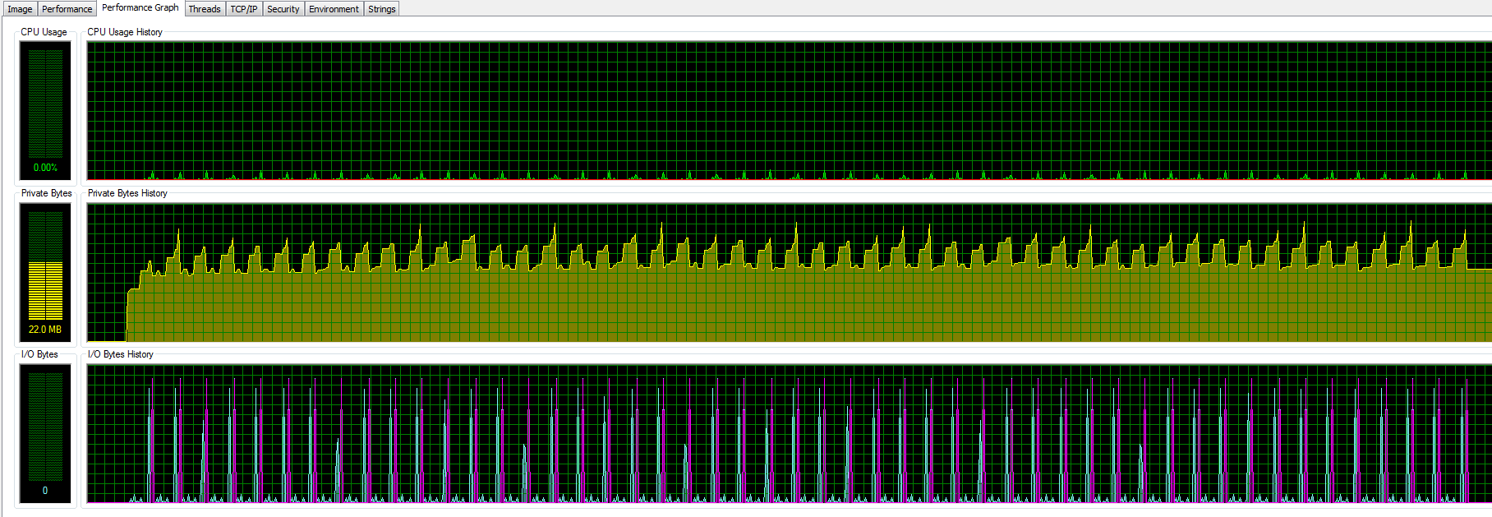

Bond Projections x 10 (no caching)
Stable
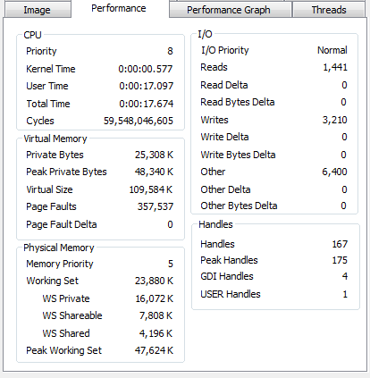

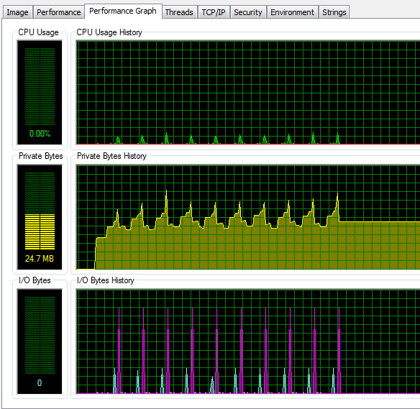
Bond Projections x 100 (with caching)
Stable
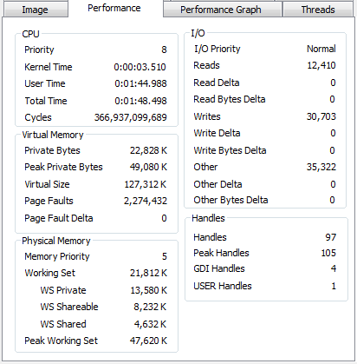

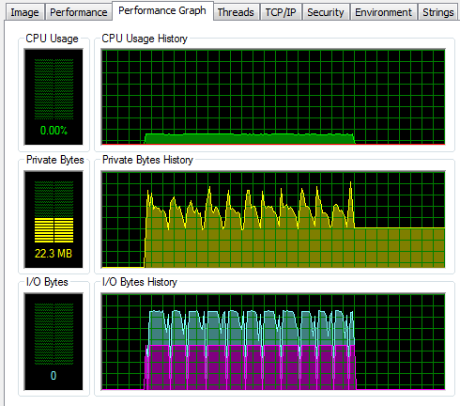

Bond Projections x 50 (no caching)
Stable

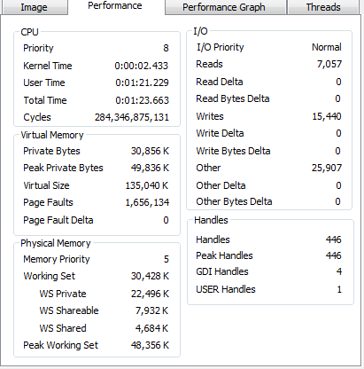

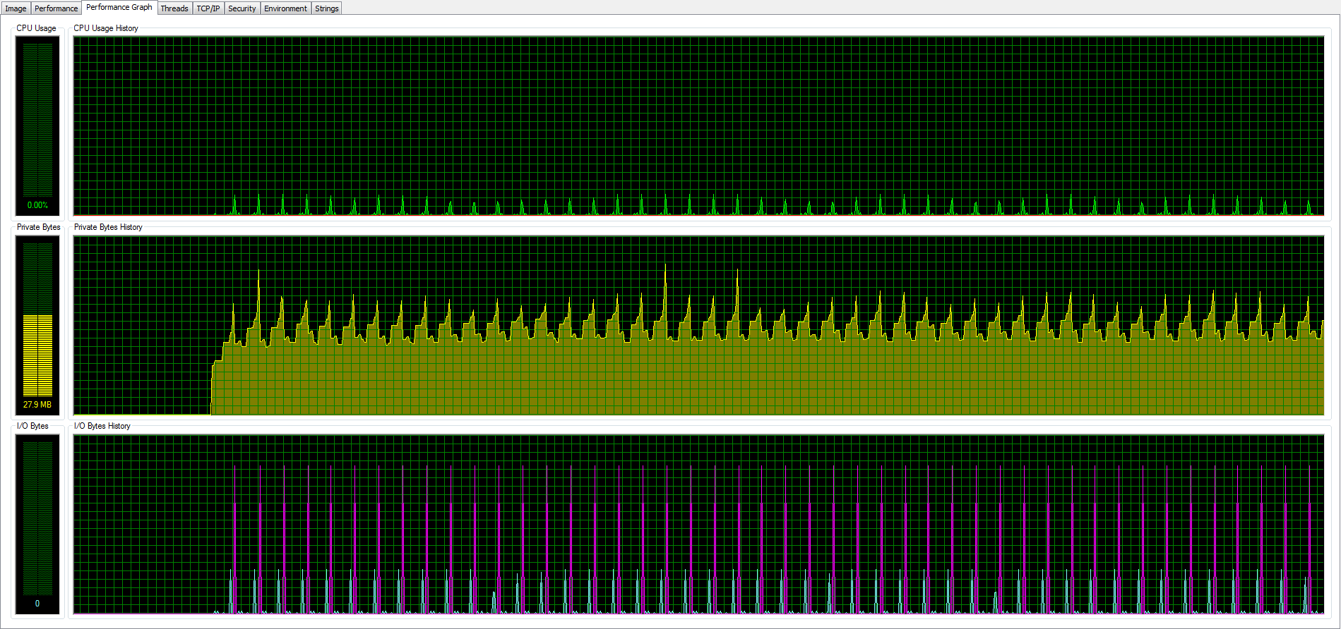

Cashflow Projections x 10 (no caching)
Stable

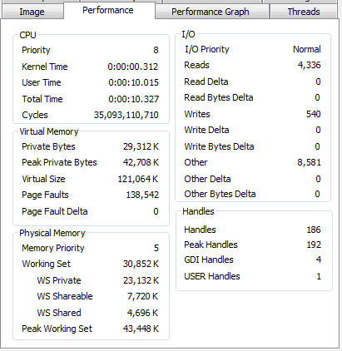

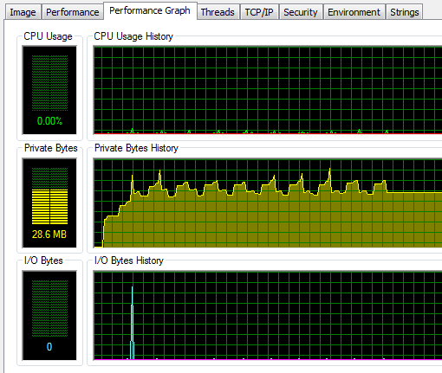
Cashflow Projections x 100 (with caching)
Stable

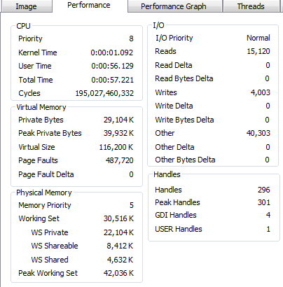

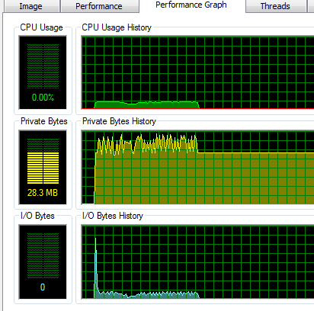

Cashflow Projections x 50 (no caching)
Stable

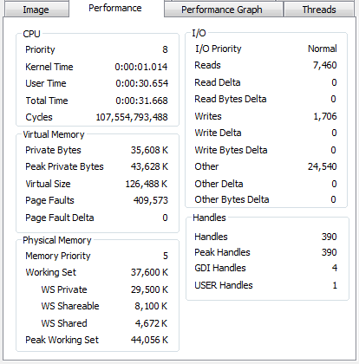

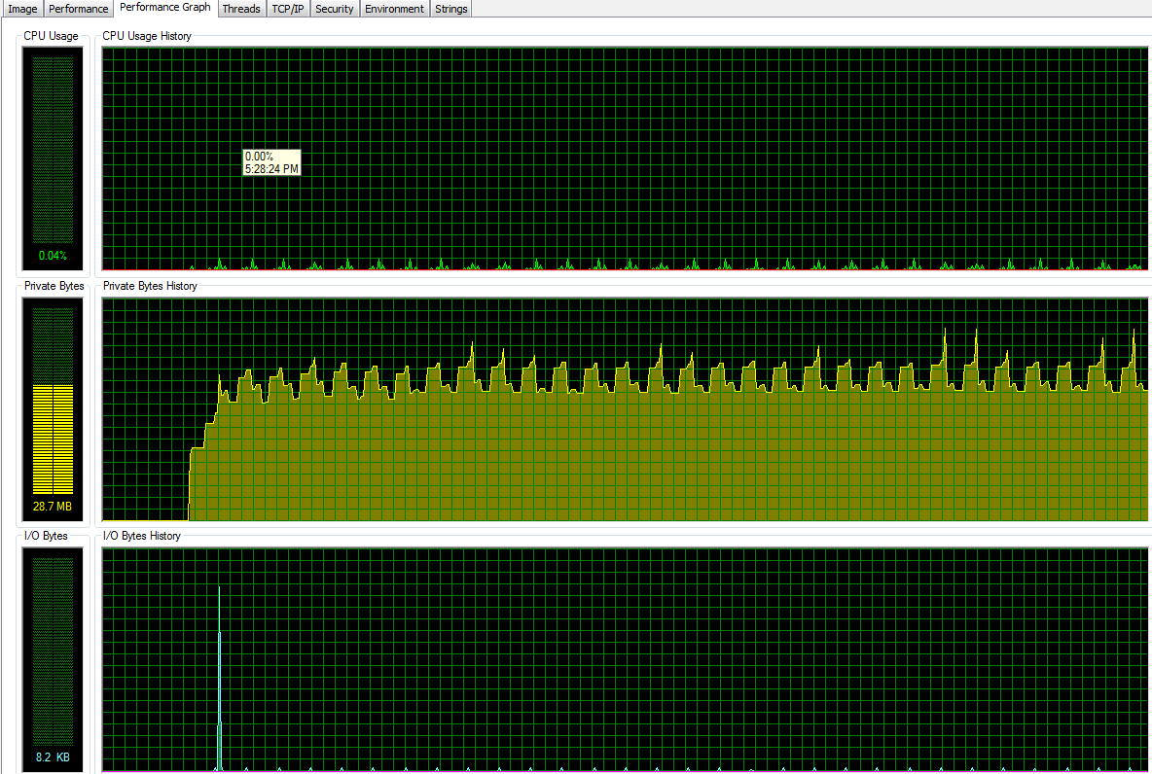

Bond Pricing x 50 (no caching)
Stable

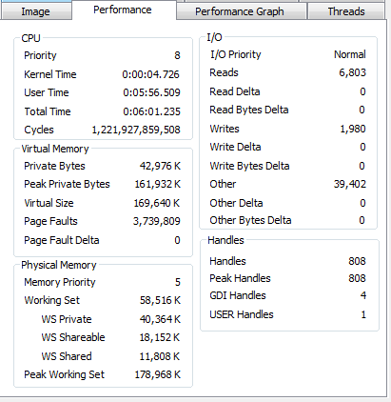

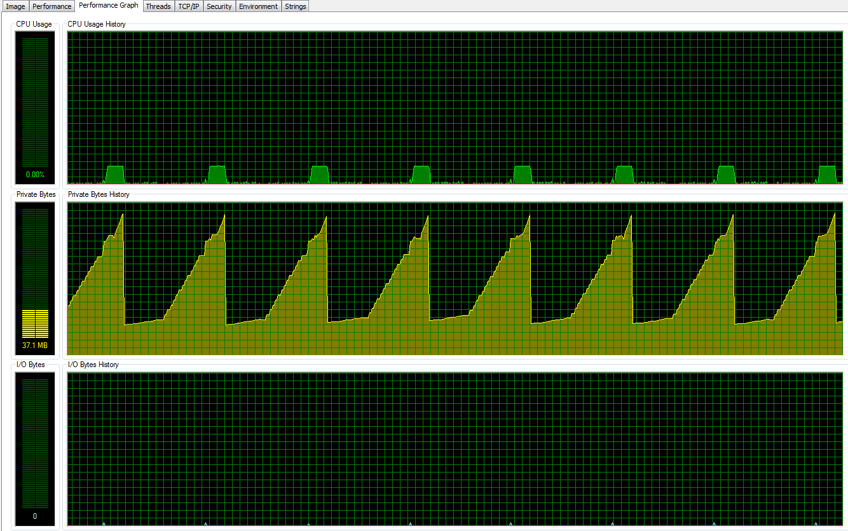

Bond Pricing x 50 (with caching)
Stable

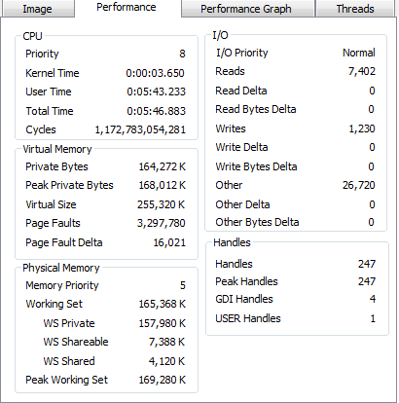

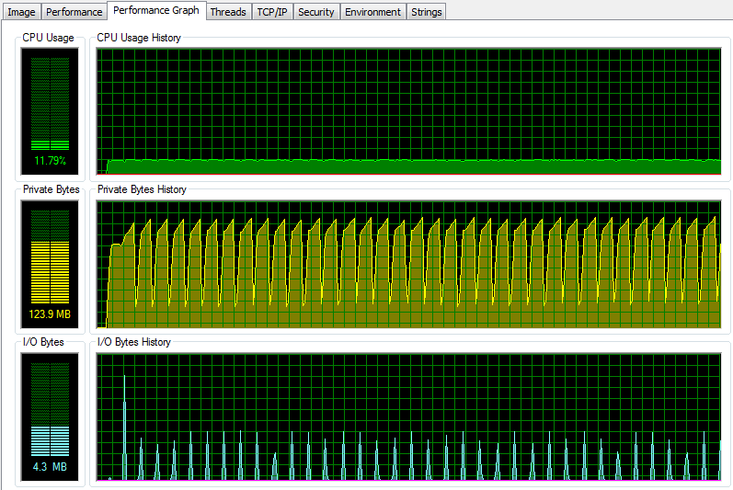

IOS Breakeven x 10 (no caching)
Stable

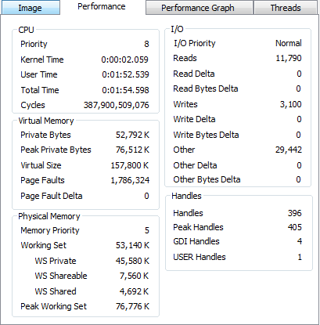

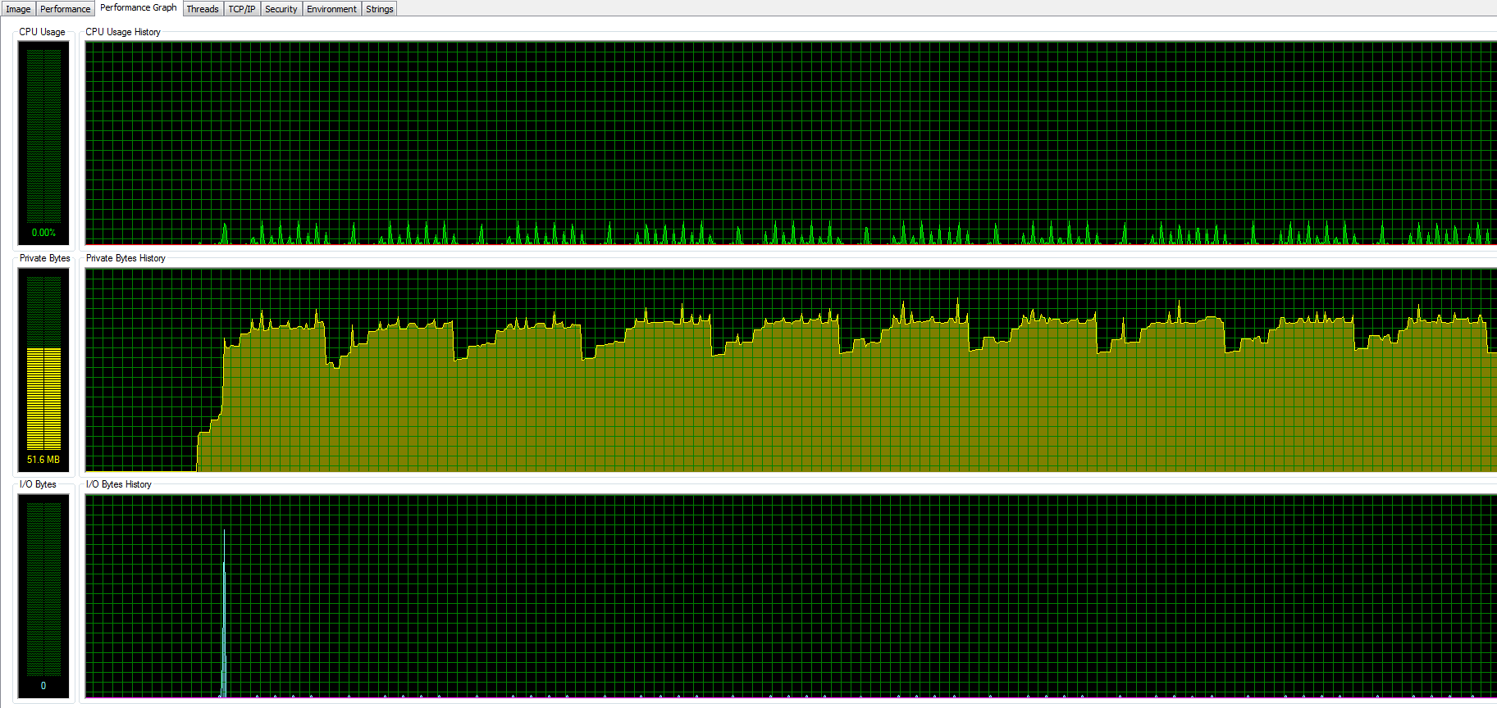

IOS Breakeven x 50 (with caching)
Not Stable (fixed 2016-08-15, see below)

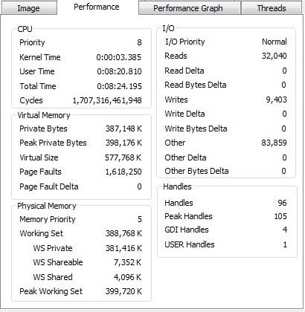

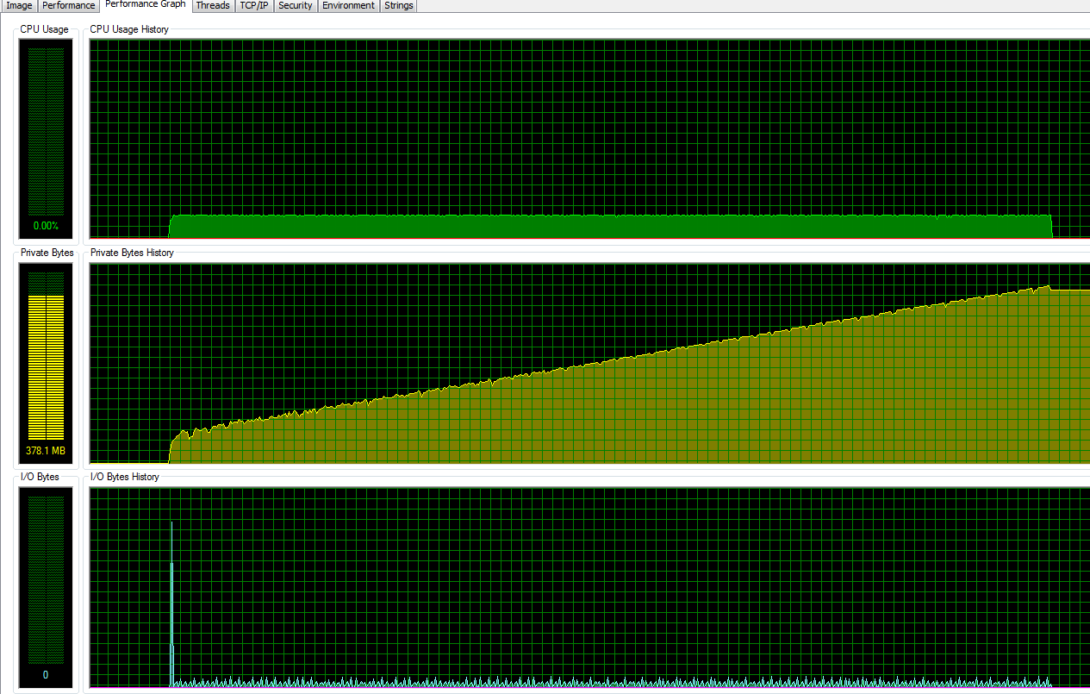

IOS Breakeven x 50 (with caching)
Stable (fixed version)

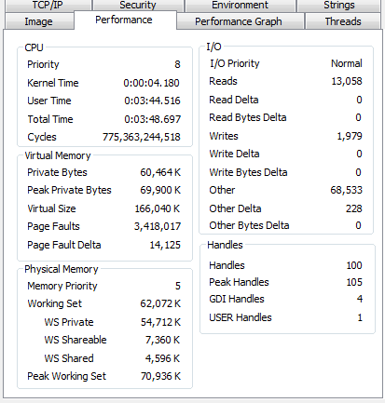
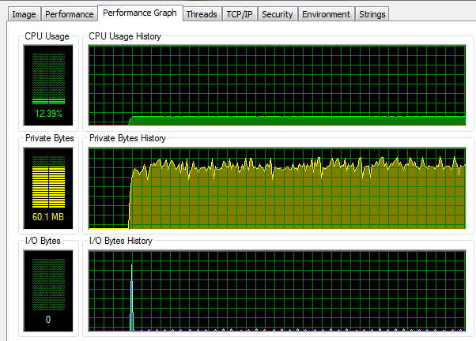
Bond Tracking x 50 (no caching)
Stable

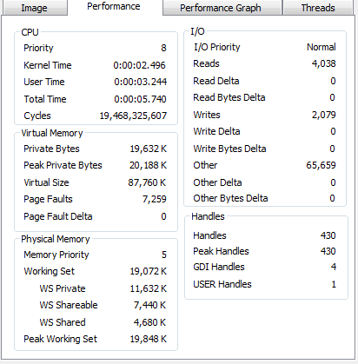

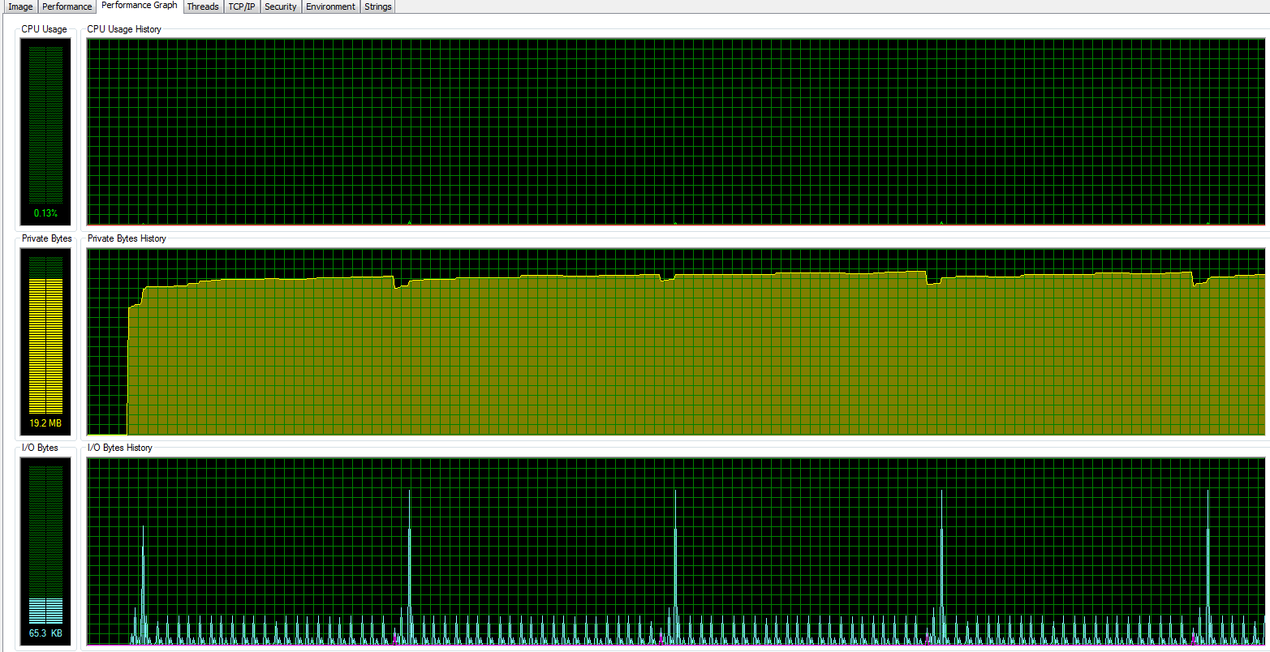

Bond Tracking x 50 (with caching)
Stable
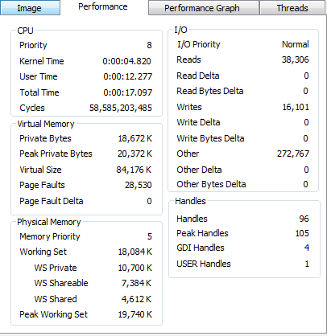

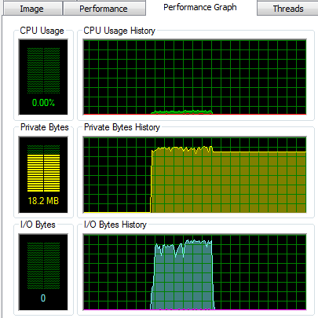

https://msdn.microsoft.com/en-us/library/wz223b1z.aspx

Memory profile on 4 Scale Workers during Bond Pricing.
The peak for each is around 1.2 - 1.7 GB range. After the calculation is completed, the memory usage came down to 225 - 270 MB range. However, we do observe that after several runs, the “rest” memory usage does go up to 290 to 300 MB.

